**Details of your portfolio**

PD URL site *(*Compulsory to fill up for milestone 2 and 3):*

[*c390-portfolio-development-two.vercel.app*](https://c390-portfolio-development-two.vercel.app/)

Name of your portfolio:

*Lionel Sem*

Your Logo:

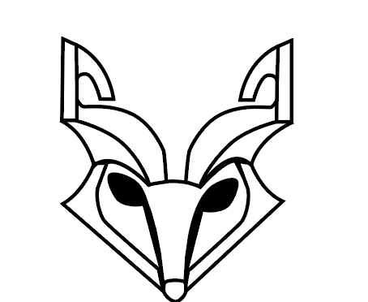

Describe your target audience:

***Target Audience of your portfolio:***

* + *Employer*

***Profile:***

* + *Age: 20 – 50 years old*
  + *Gender: All Genders*
  + *Income Bracket: Mid to high Income earners ( $2,000 - $6,000)*
  + *Education: Higher Nitec, Polytechnic diploma or University degree (IT-Related)*
  + *Computer Literacy: Basic to advance foundational knowledge in key programming and database languages ( Python, SQL, CSS,HTML, and JavaScript)*
  + *Familiar with digital portfolios and standard design*

Describe your brand story/ purpose:

*I am an aspiring full stacked developer with a foundation in Python, SQL, HTML, CSS, and JavaScript, and a passion for building a unique user experience and efficient digital solutions. My inspiration to pursue software development comes from my imagination. As a person who have strong imagination, I would like to make my imagination come true. I enjoy working on projects that combine both technical learning and creative design, and I am motivated by the opportunity to grow my skills while contributing to meaningful solutions. With a oriented mindset, adaptability, and a drive for continuous improvement, I am to bring my value to my now and future team members.*

**Design brief**

My portfolio is designed to present my work in a clean, modern, and luxurious way. The visual direction uses a refined neutral-blue palette to communicate professionalism, calmness, and a premium feel while keeping readability high. Dark “Ink” tones are used for typography to create a strong contrast without the harshness of pure black, maintaining a softer and more contemporary interface. Muted slate and mist blues support secondary text, icons, and accents to reinforce a tech creative identity without overpowering the content.

To ensure clarity across sections, light “paper” neutrals form the foundation for glassmorphism cards, allowing text and project details to remain eligible even over a textured or photographic background. Accent blues are applied selectively to interactive states ( such as navigation cues, tags, and hover) to guide attentions and signal layout and keep focus on the most important content.

Color Palette: <https://www.figma.com/design/uUeI18mI3oXZB0AsnzrBMG/Color-wheel-palette-generator--Community-?node-id=0-1&t=LMIdpoJW78GsI8BQ-1>

* **Refined neutral-blue palette gives a professional, calm, premium feel while keeping content readable on a textured light backdrop.**
* **Base “ink” tones #1C1E20, #242628, #2A2D30 create strong typography contrast without harsh pure black, making the UI softer and more modern.**
* **Muted slate/mist blues #3E556A, #4F6B82, #7FA6BF support secondary text and accents, reinforcing a tech-creative identity without aggressive saturation.**
* **Paper neutrals #F2F3F5, #D1D3D6 enhance light glassmorphism surfaces and keep cards legible over the photographic background.**
* **Accent blues #7FA6BF / #3E556A highlight interactive states and UI details (nav underlines, tags) without overwhelming content.**
* **Soft gradients, translucent whites, and blurred overlays unify sections and keep attention on projects and certifications, creating a clean, employer-friendly presentation.**

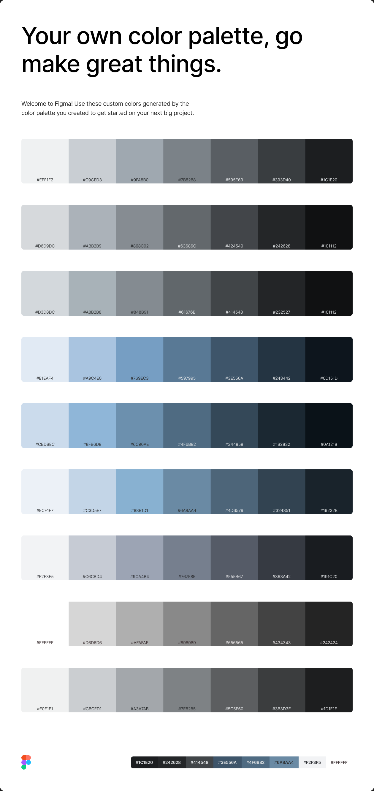

**Monochrome grayscale palette**

Typography:

***Manrope***

Theme:

***Minimalistic luxurious Theme***

Layout/ Arrangement:

*How will you arrange the multimodal composition in a way that makes sense for your audience and your purpose? How might you arrange ideas and elements so that your composition is effective?*

***Minimally 3 tabs with 2 layers of navigation***

Opening page

Home

About

Certificates

Contact

Project

Web Development

Mobile Development

Game Development

Design

All

Design

* **Uses a clear, section-based layout with a fixed header so navigation stays visible and scrolling effort is reduced.**
* **A centred container (max-width ~1100–1200px) keeps text readable on wide screens while preserving generous spacing.**
* **Hero section follows a two-column split: left for intro text + calls-to-action, right for a large visual card, so identity and key actions are clear immediately.**
* **About section keeps the same two-column rhythm (image + text) to maintain balance, hierarchy, and consistency.**
* **Projects and certifications use responsive auto-fit grids so content scales smoothly across different screen sizes.**
* **Certifications can switch to a horizontal carousel on smaller screens, keeping items visible without overcrowding the page.**
* **Services are presented in a consistent card grid for quick scanning.**
* **Contact section is a unified two-panel card: larger form on the left, and a darker high-contrast details panel on the right, creating a strong visual end point.**
* **Footer is minimal and centred to close the page flow cleanly.**
* **Responsive breakpoints (around 1100px, 900px, 600px) progressively move from multi-column to single-column layouts for better readability and touch-friendly spacing.**

**Low fidelity wireframe:**

*Insert your low-fidelity wireframe here. This can be photo of your sketches or digitally created low-fidelity wireframe using shapes. E.g.*

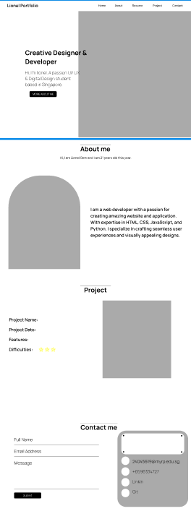

**High fidelity wireframe** *(*Compulsory to fill up for milestone 2 and 3)***:**

*Insert your high-fidelity wireframe here. Full set of ALL the pages in JPEG or PDF format.*

*E.g.*

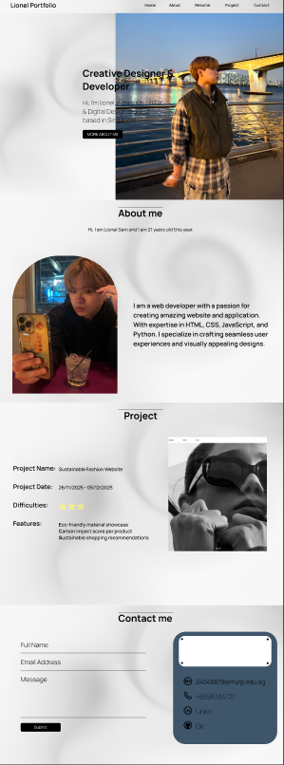

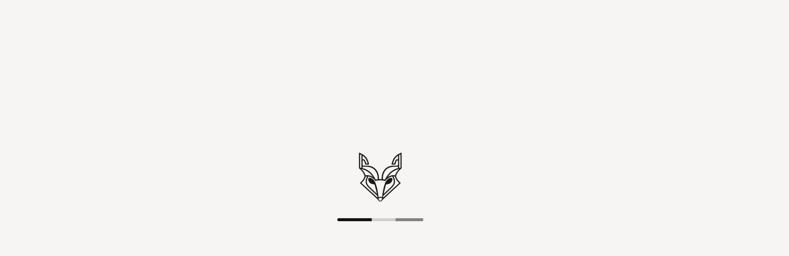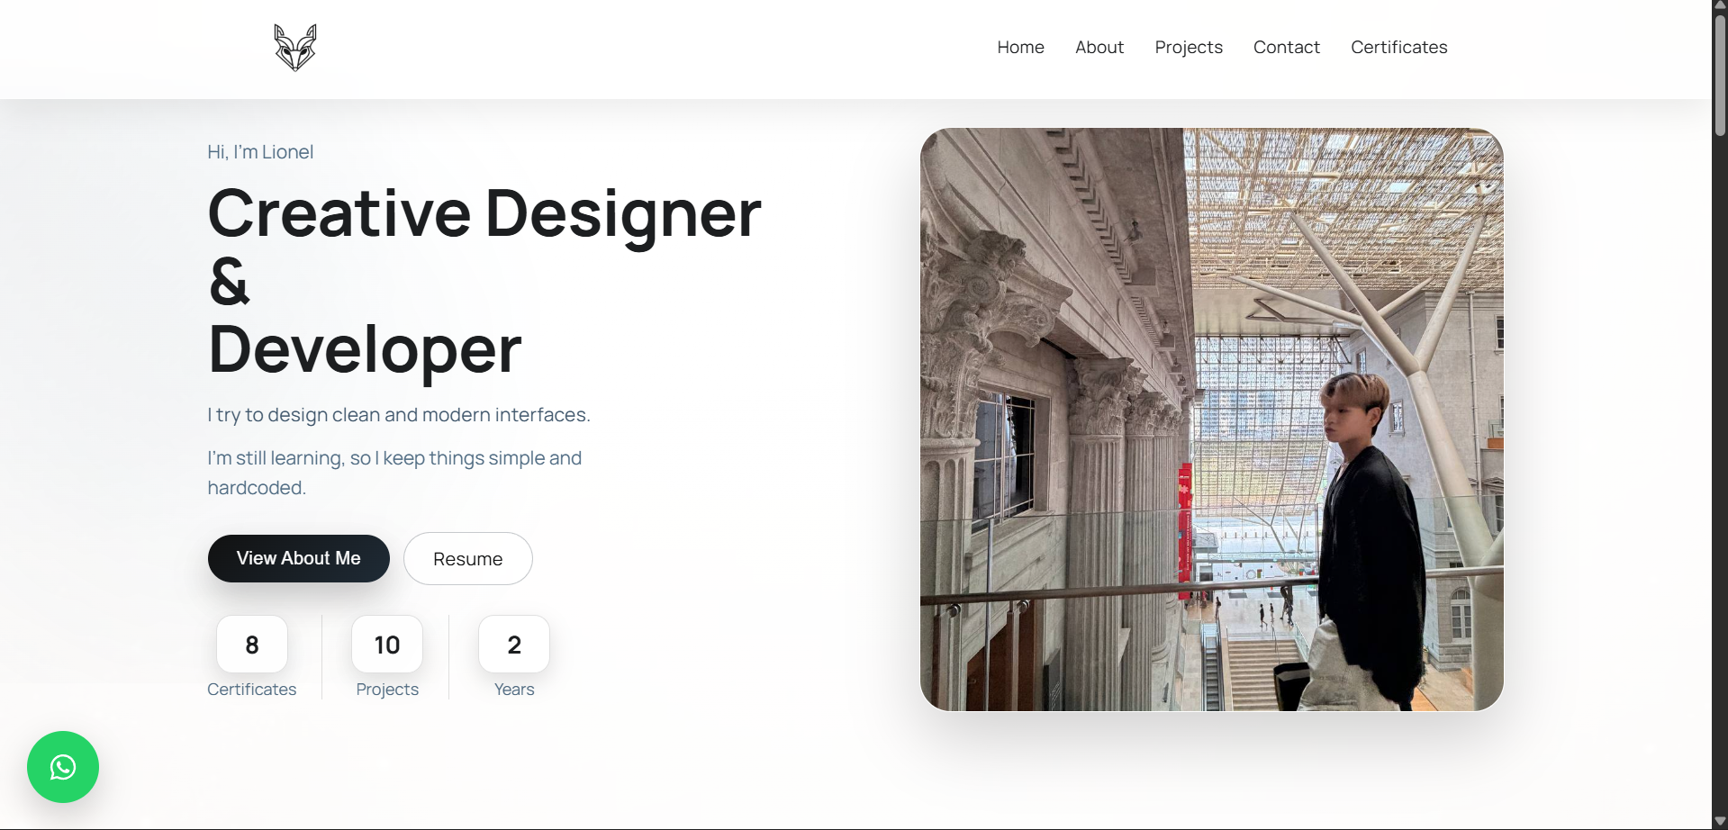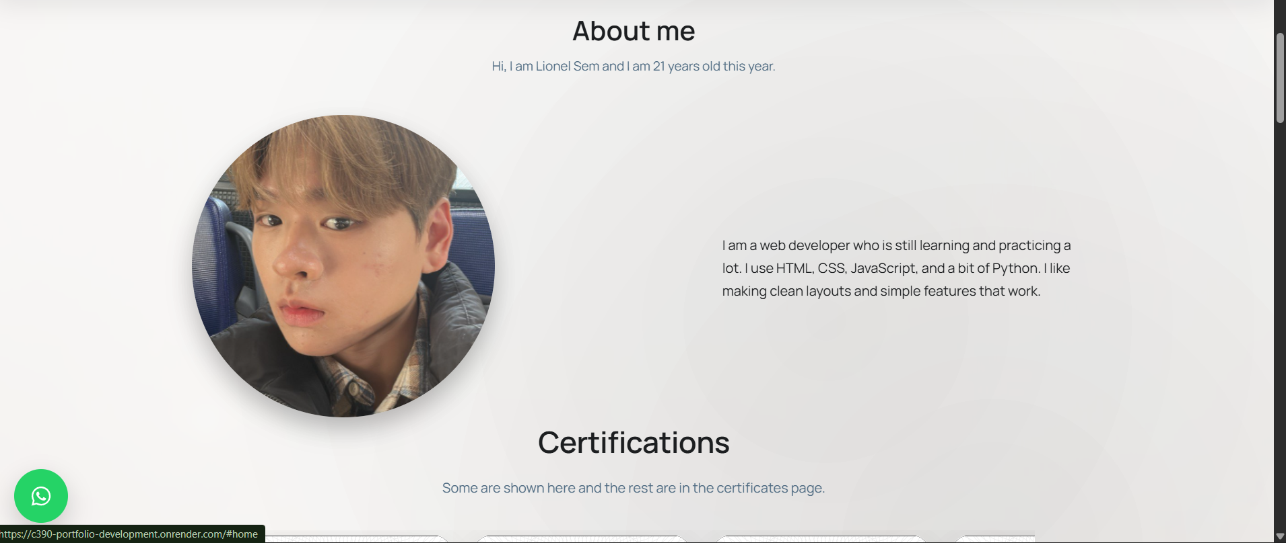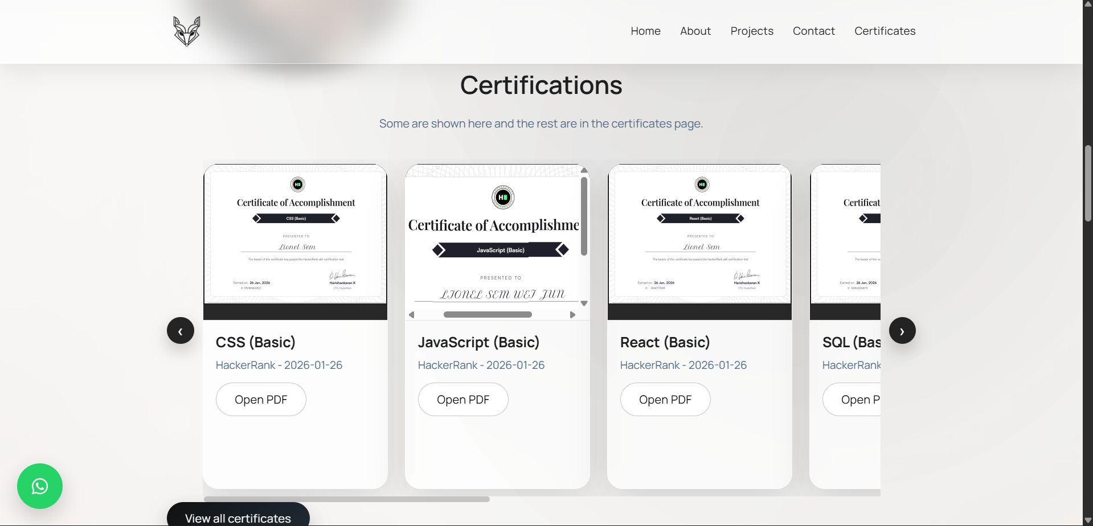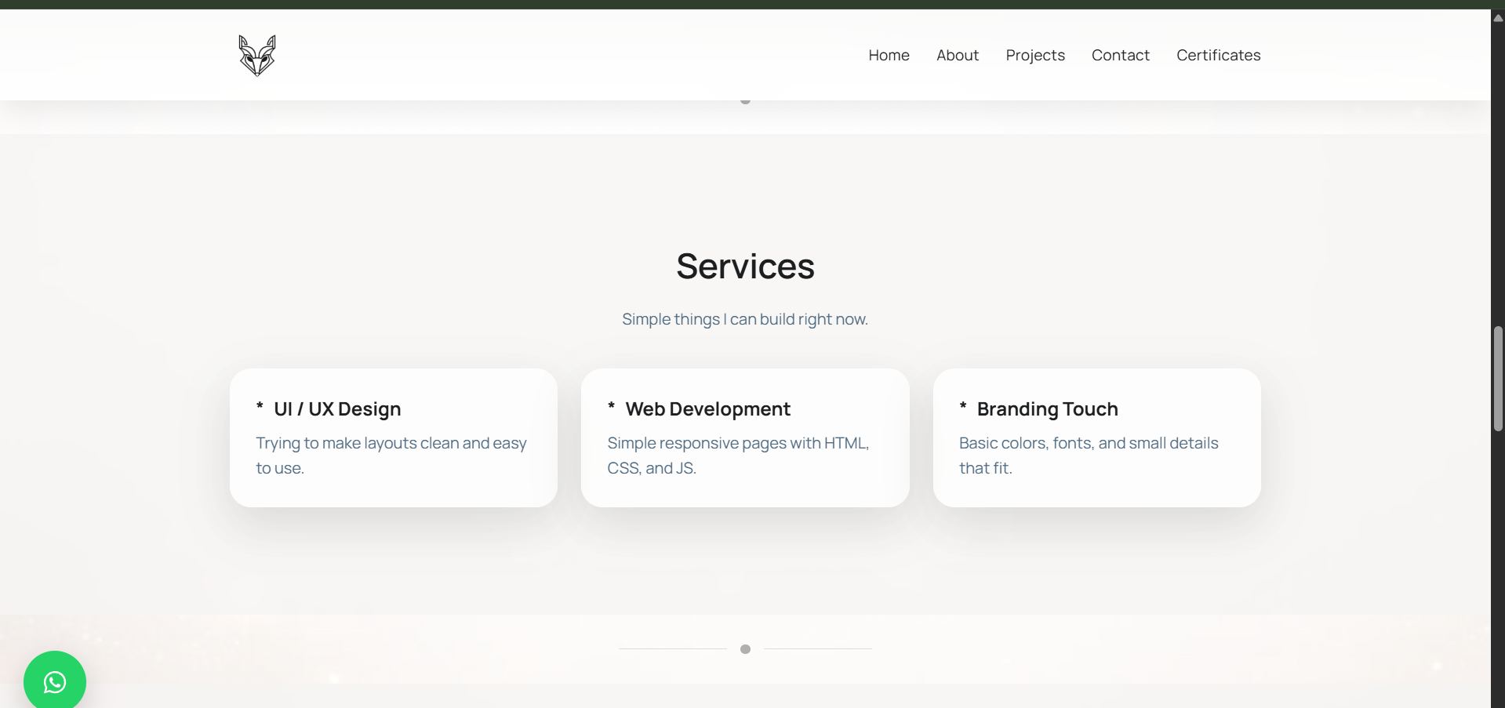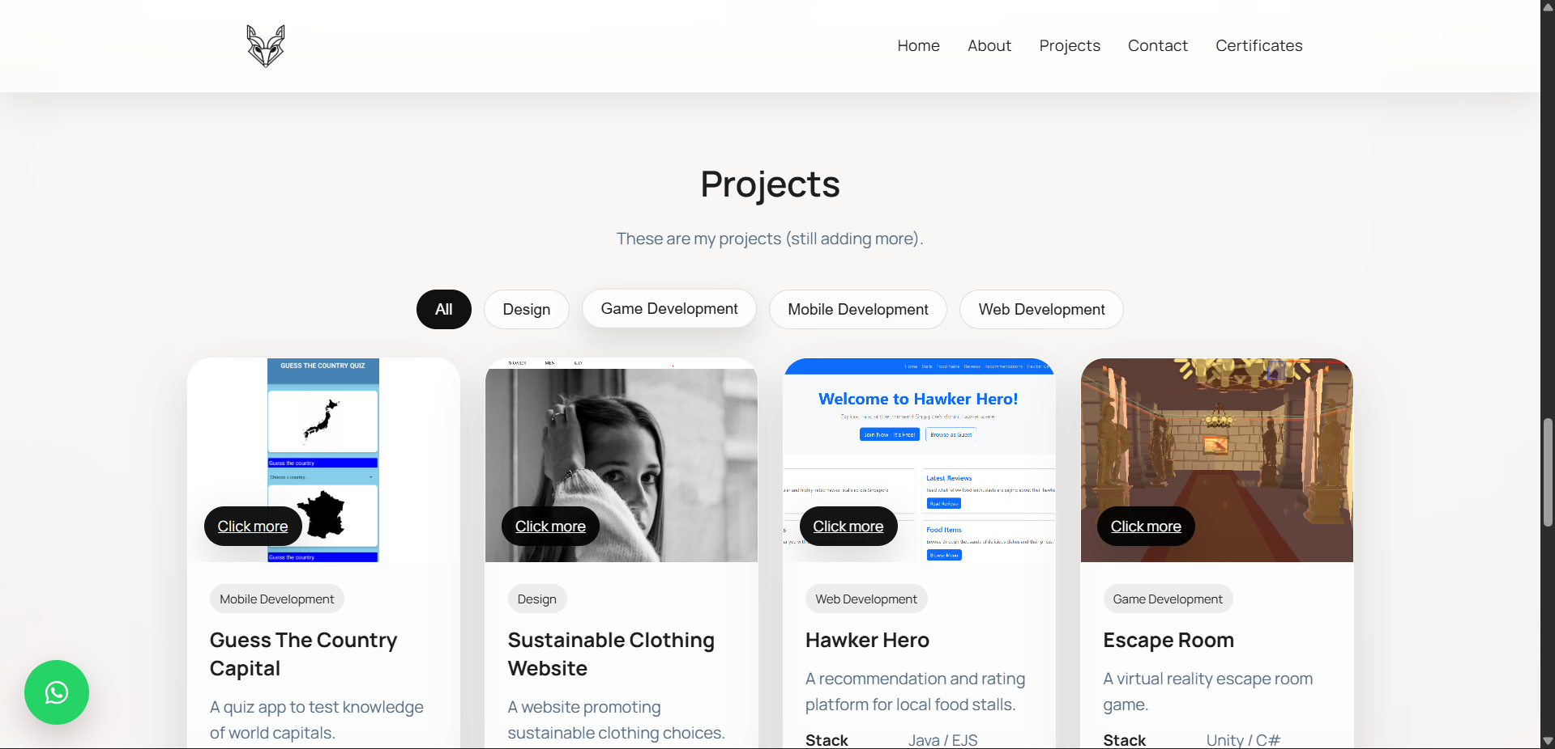

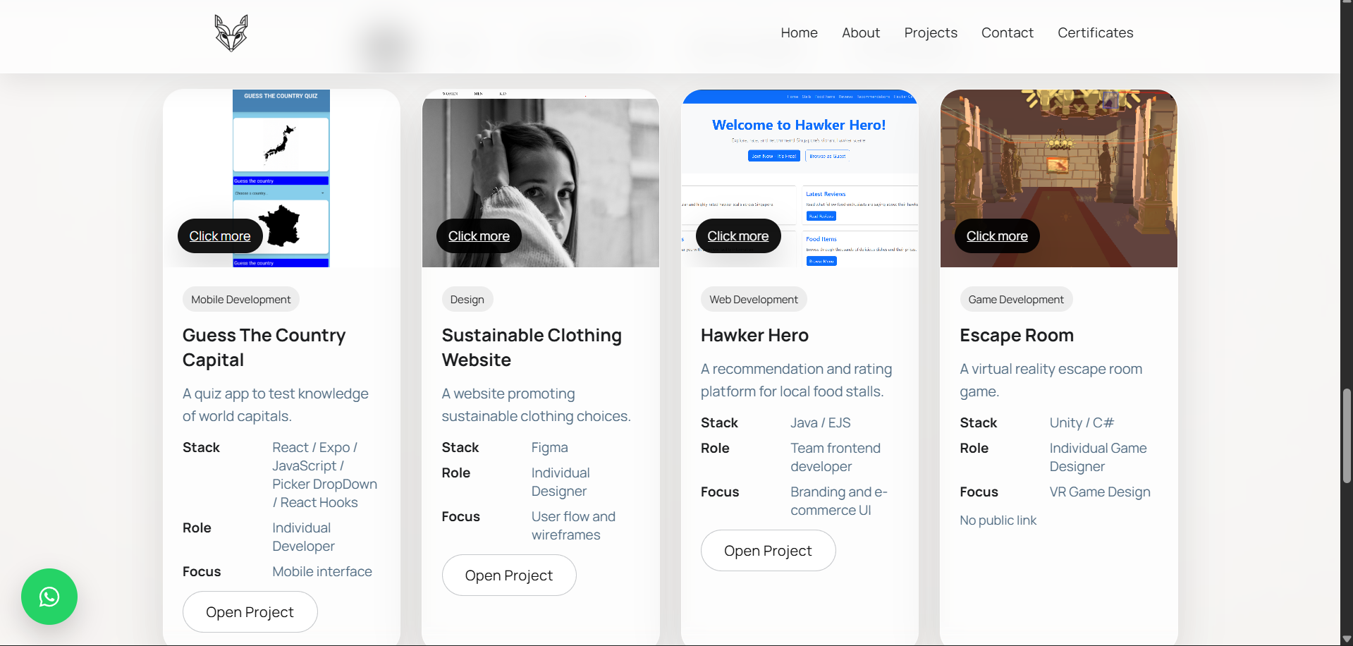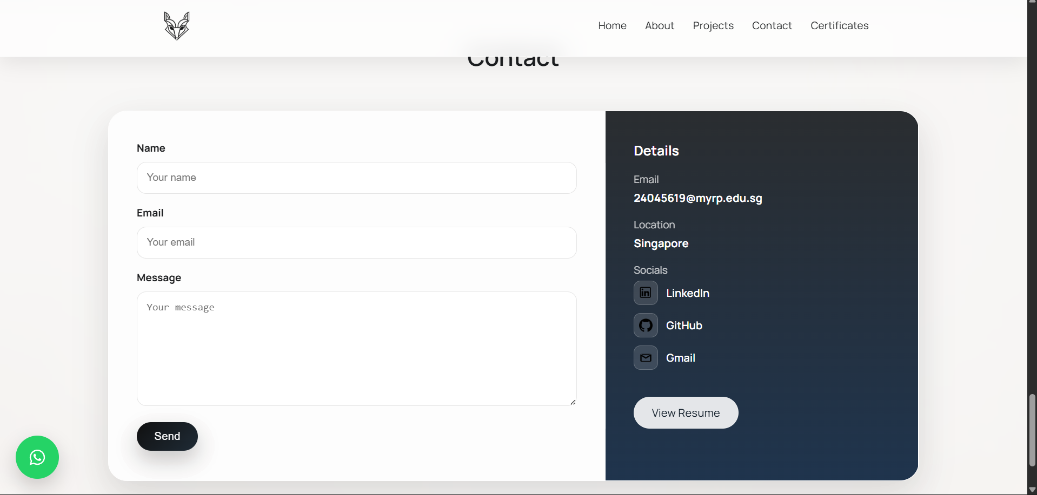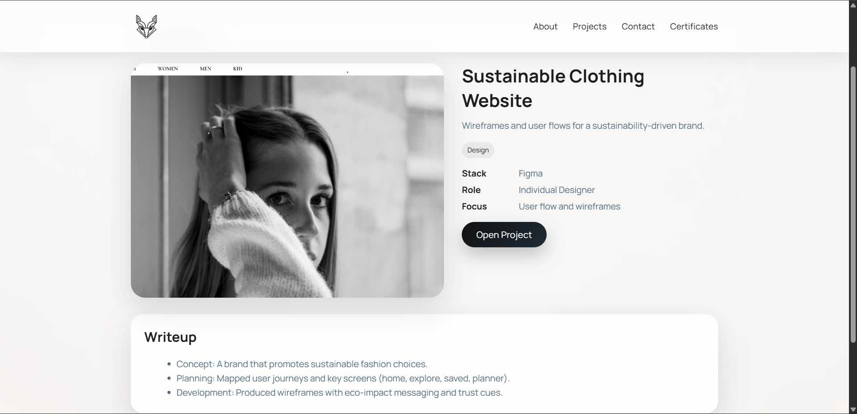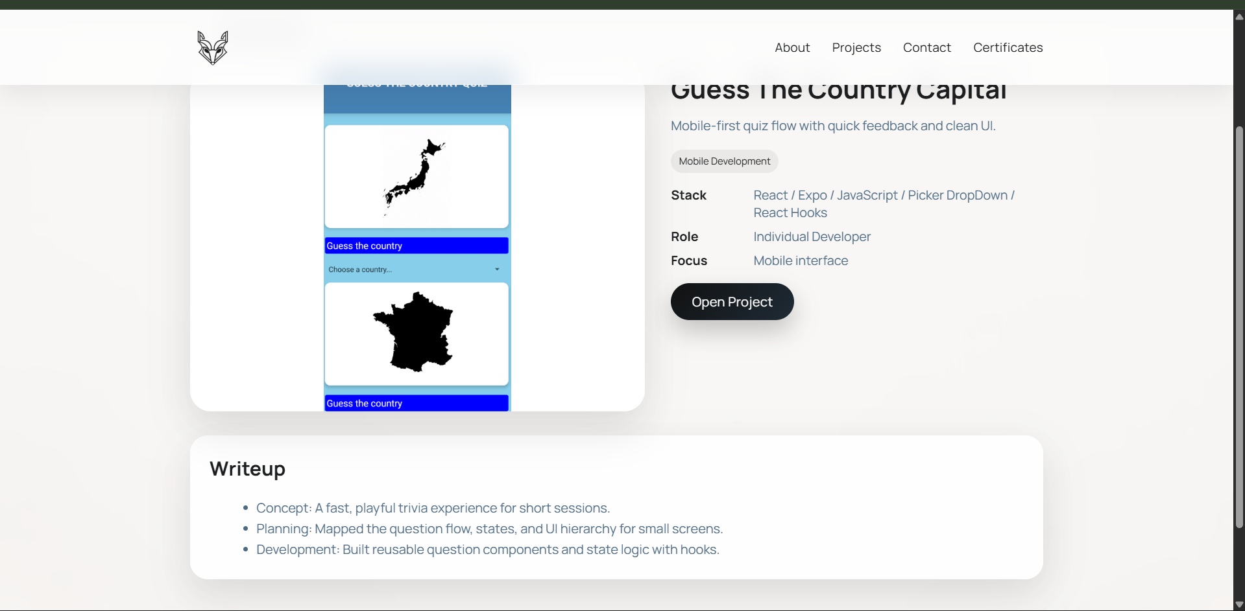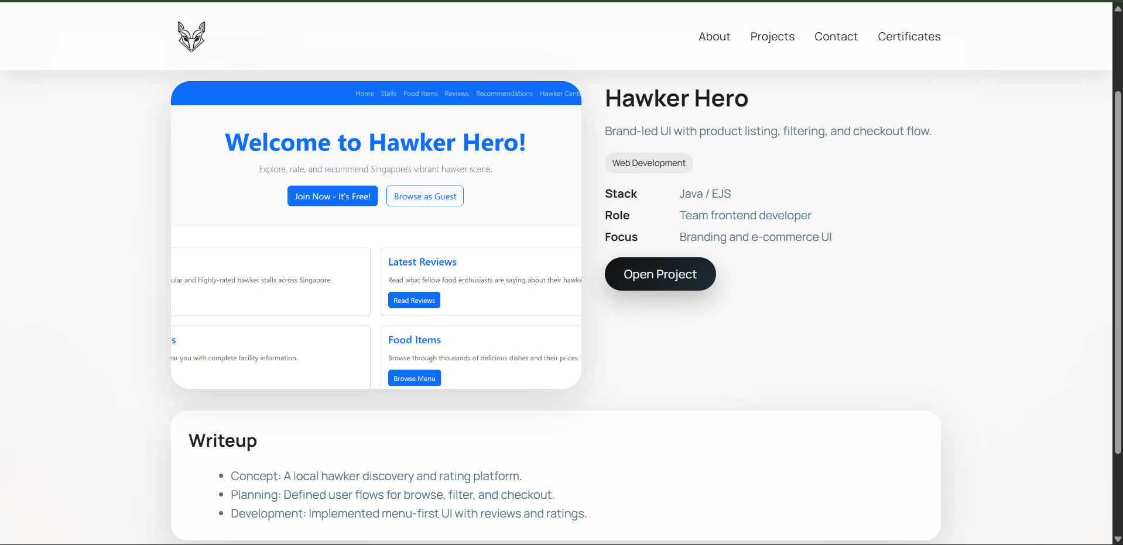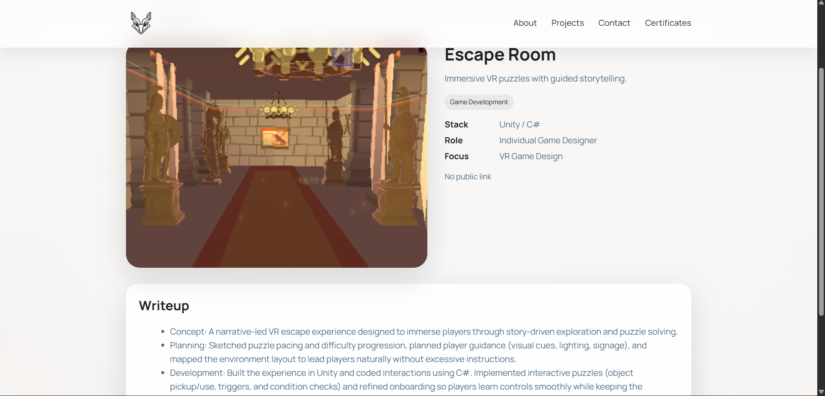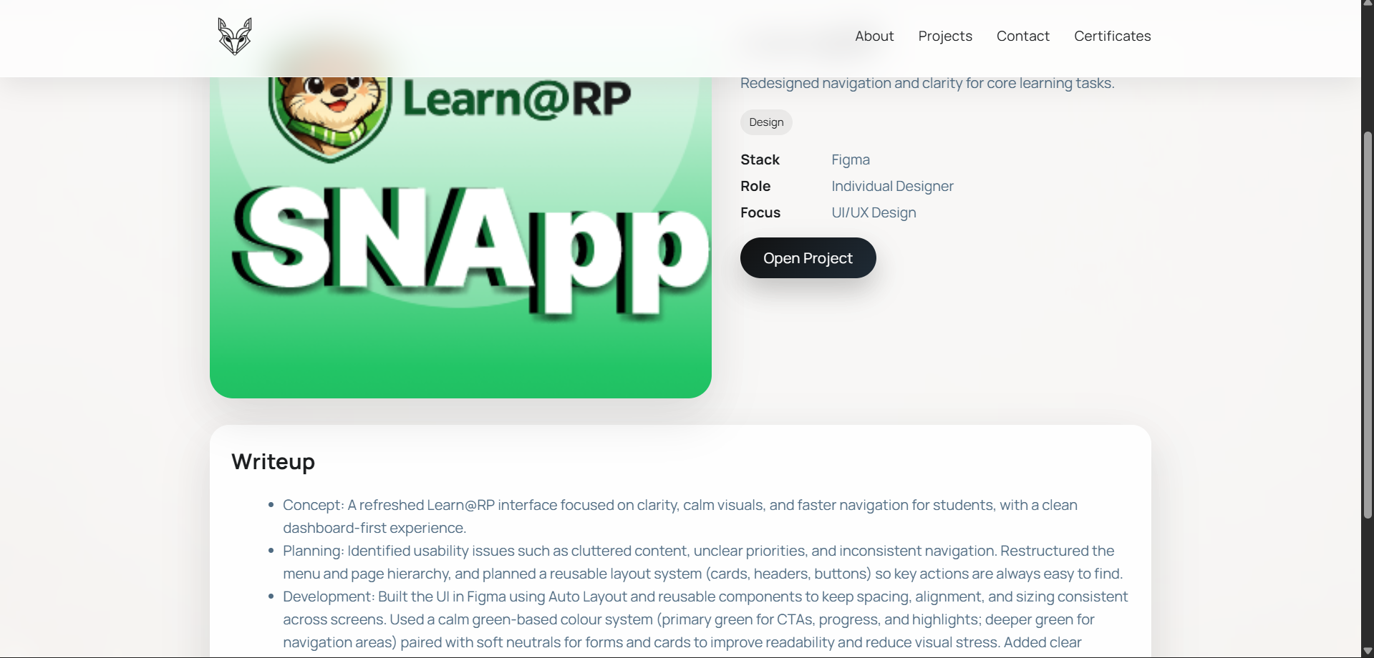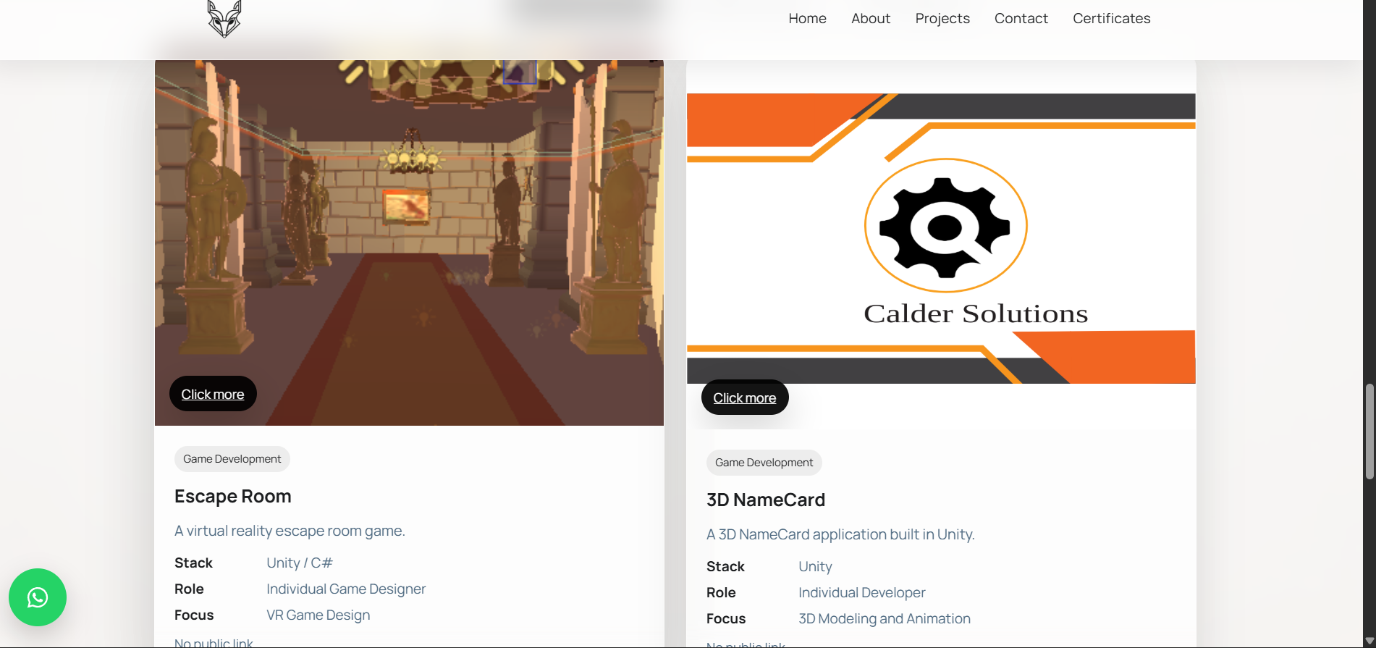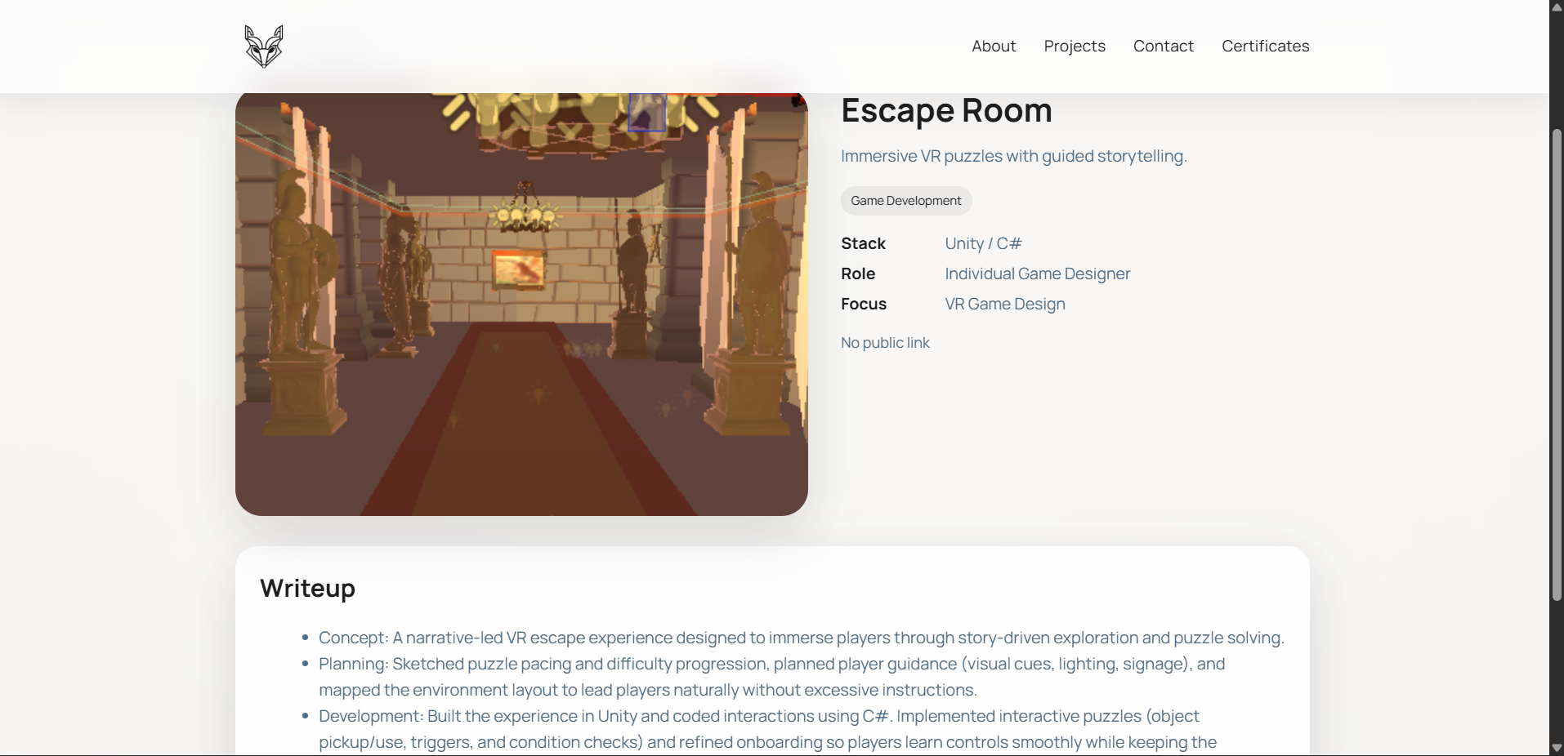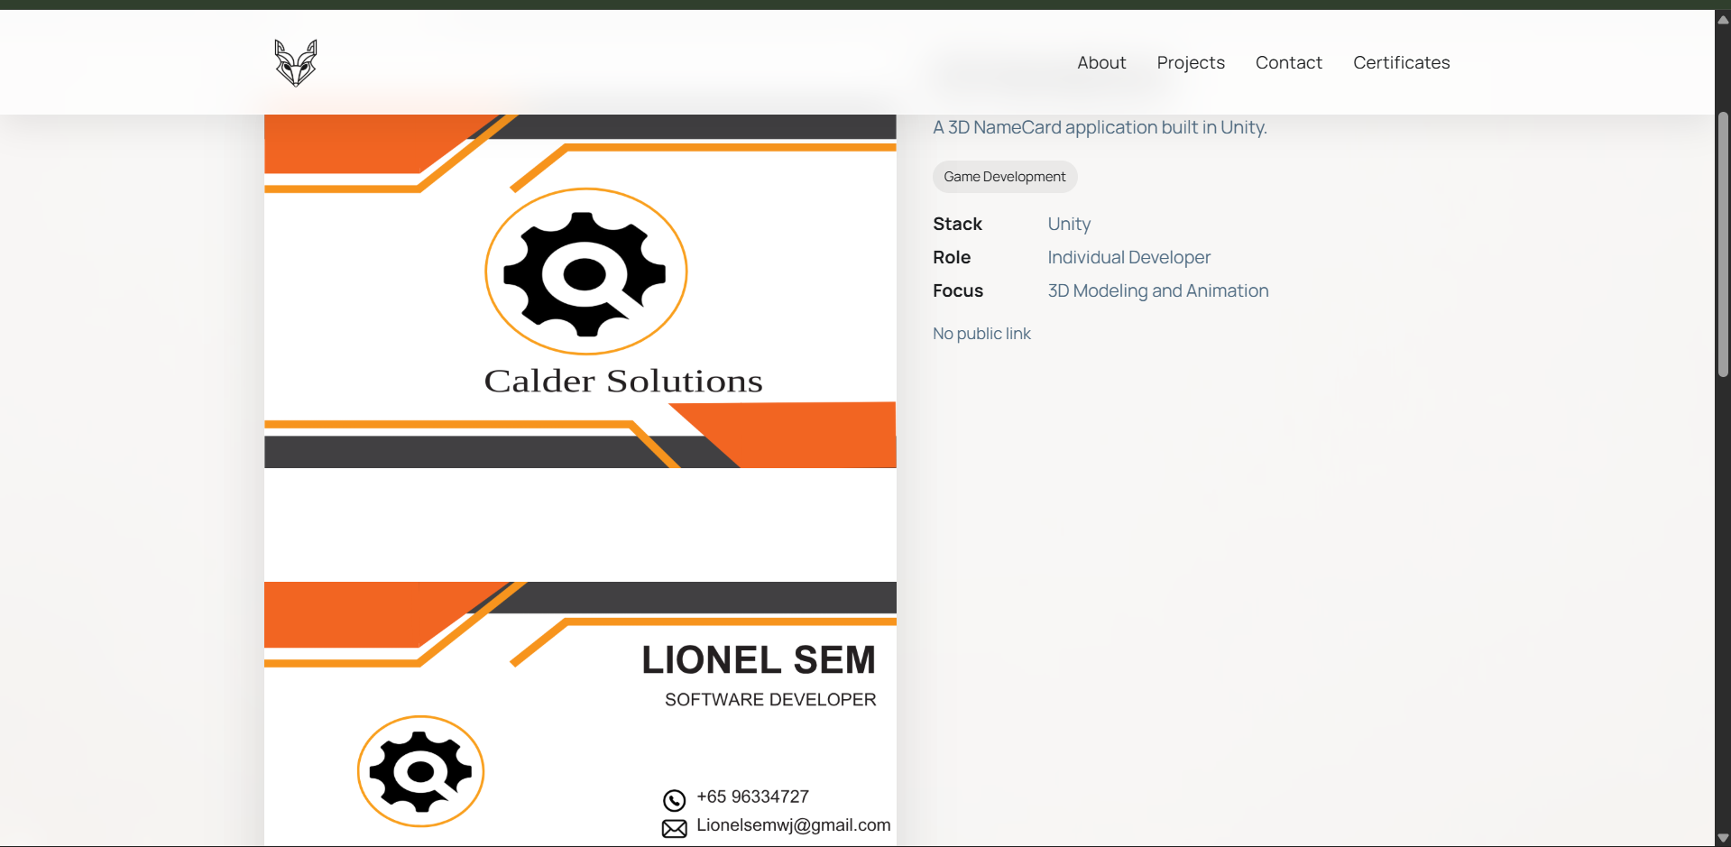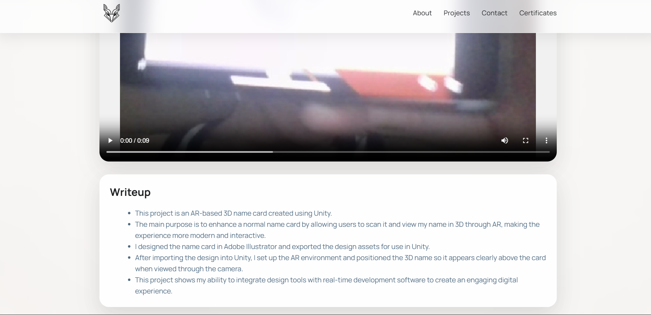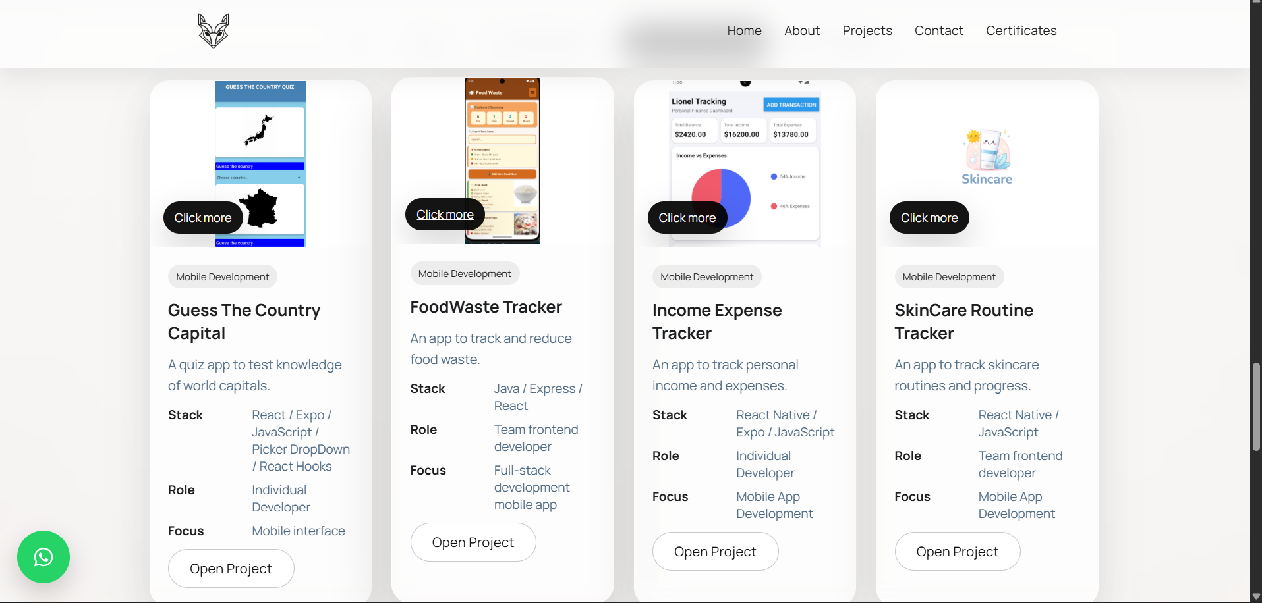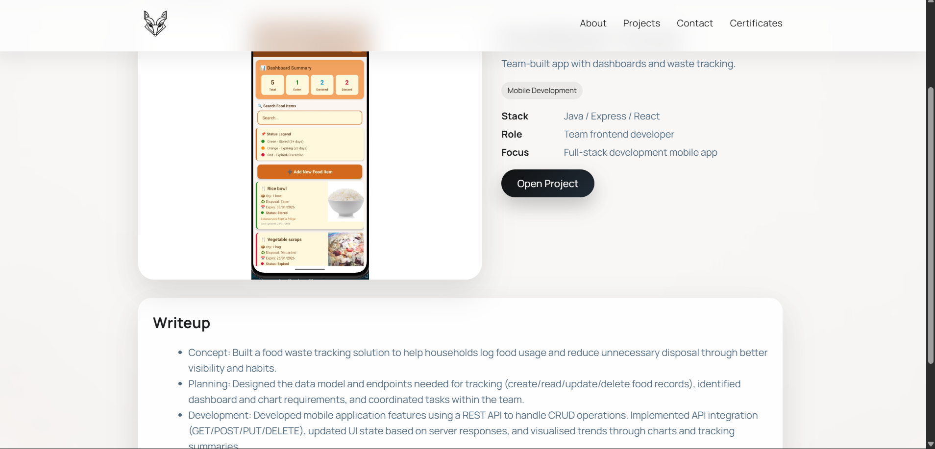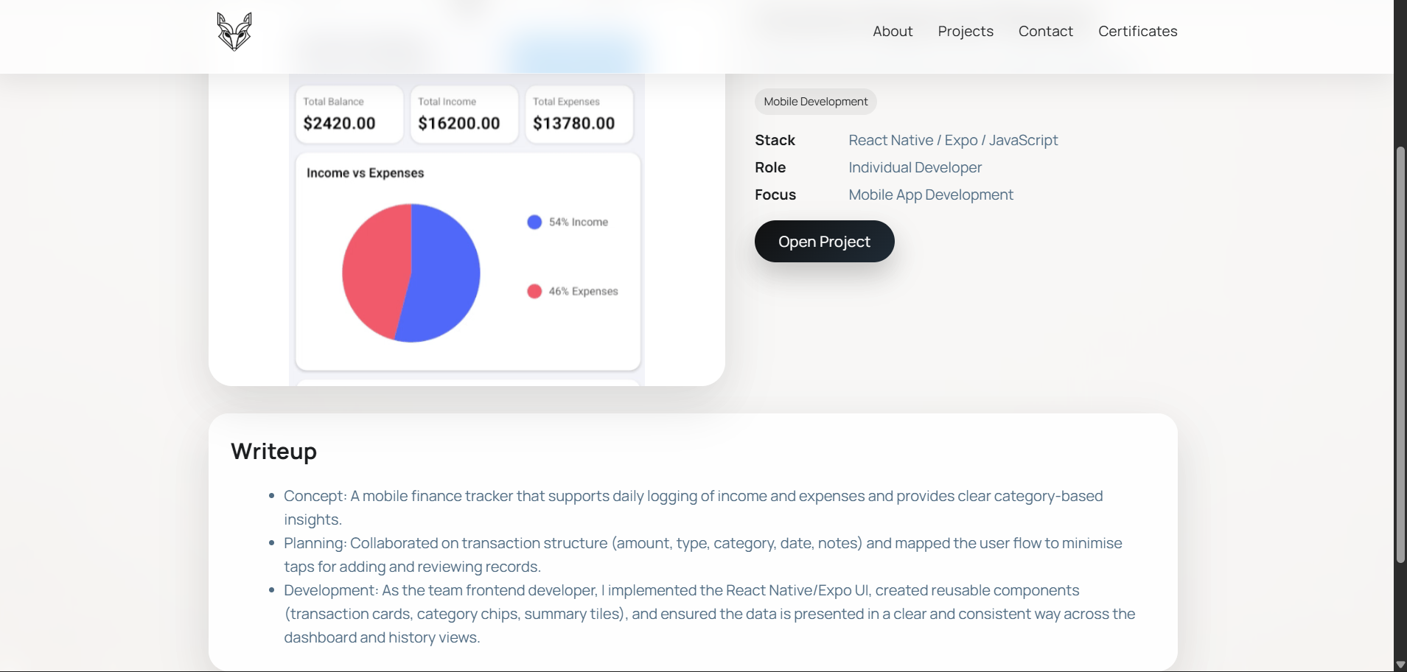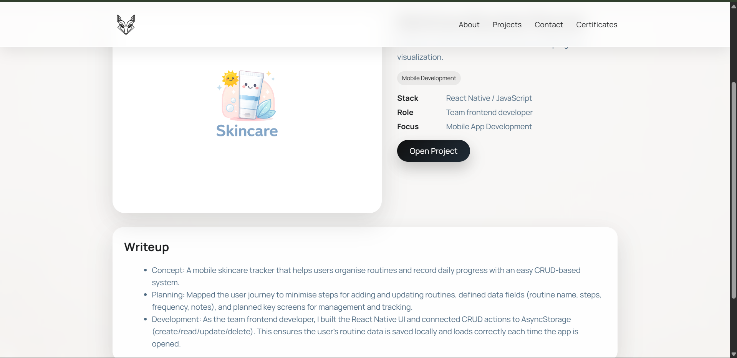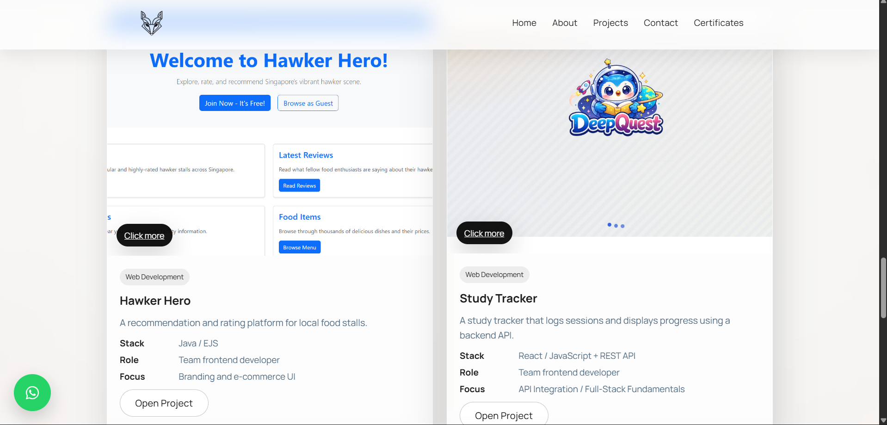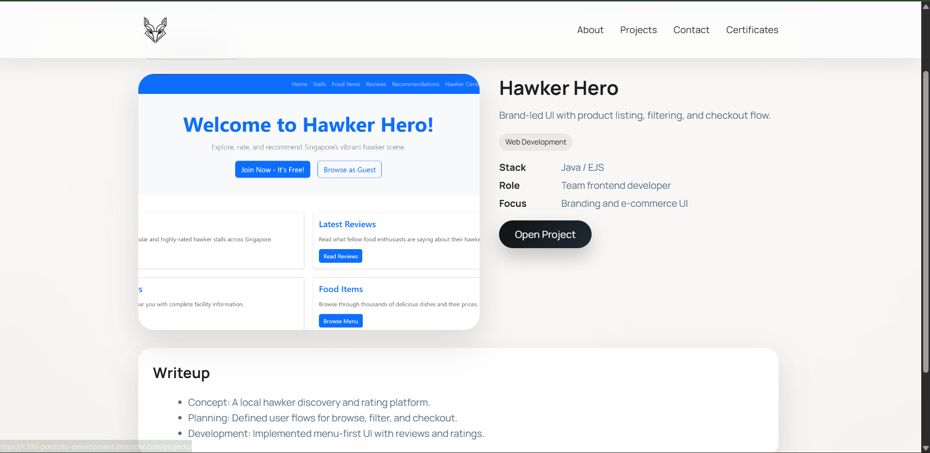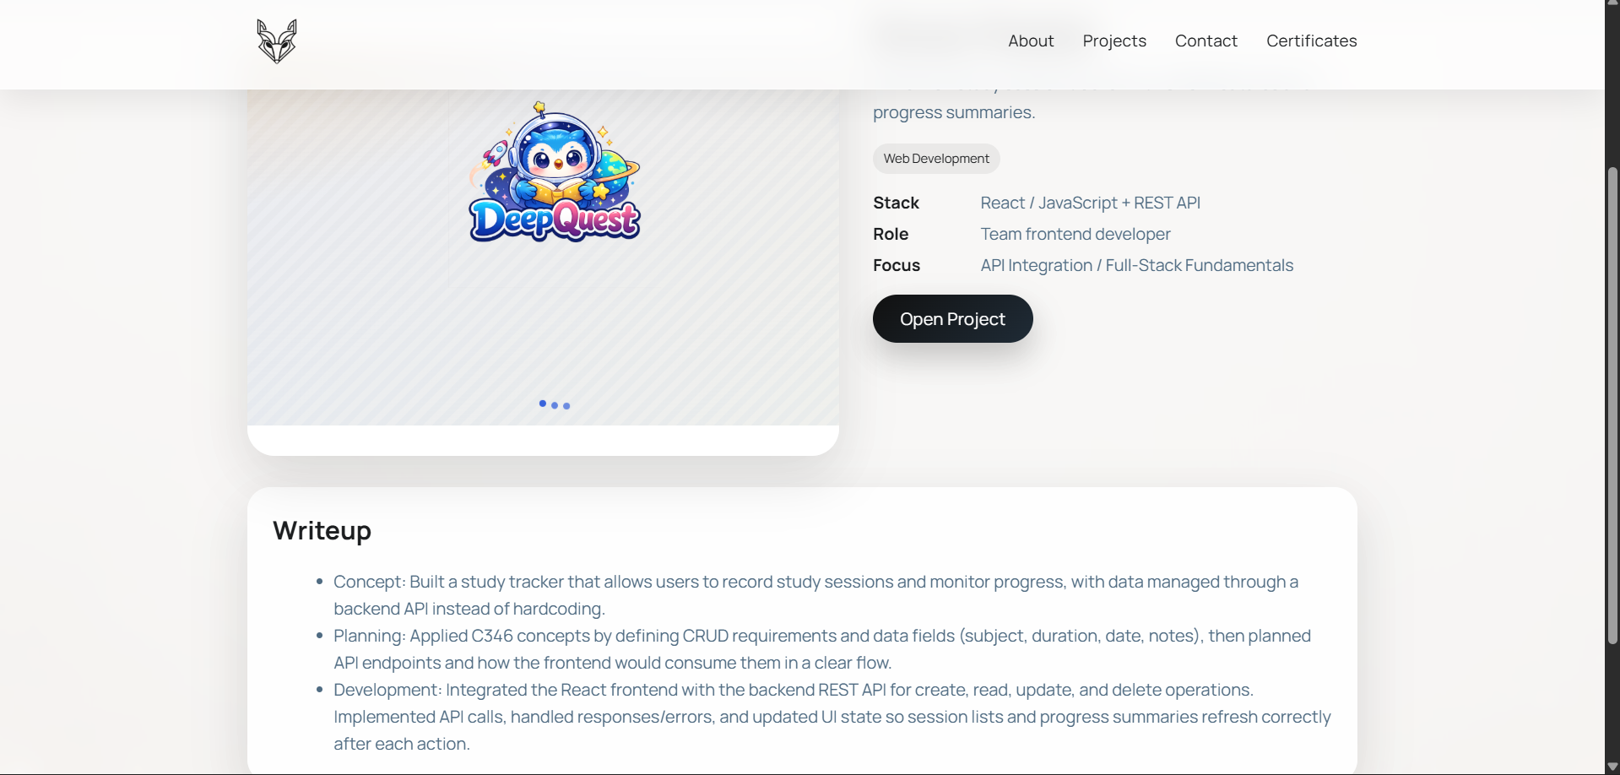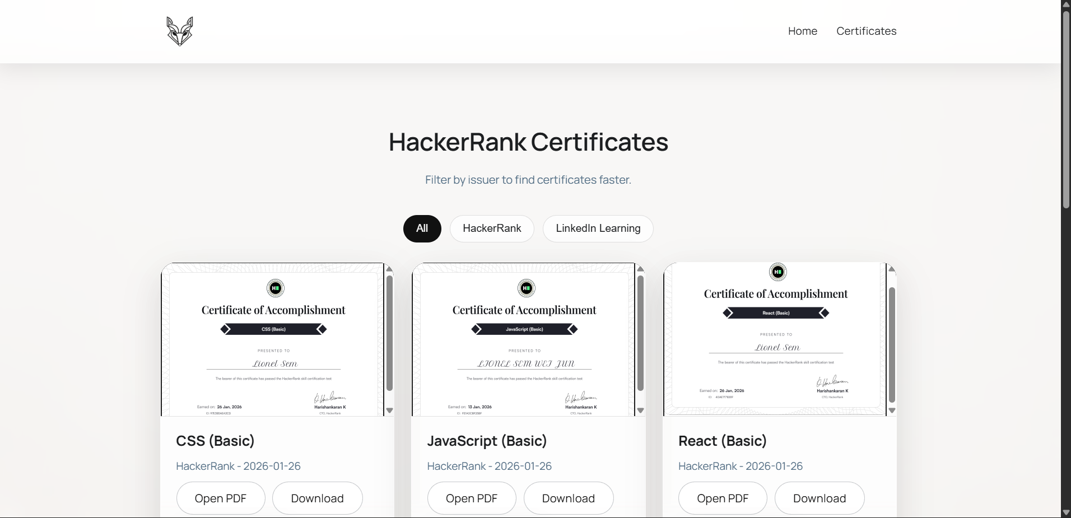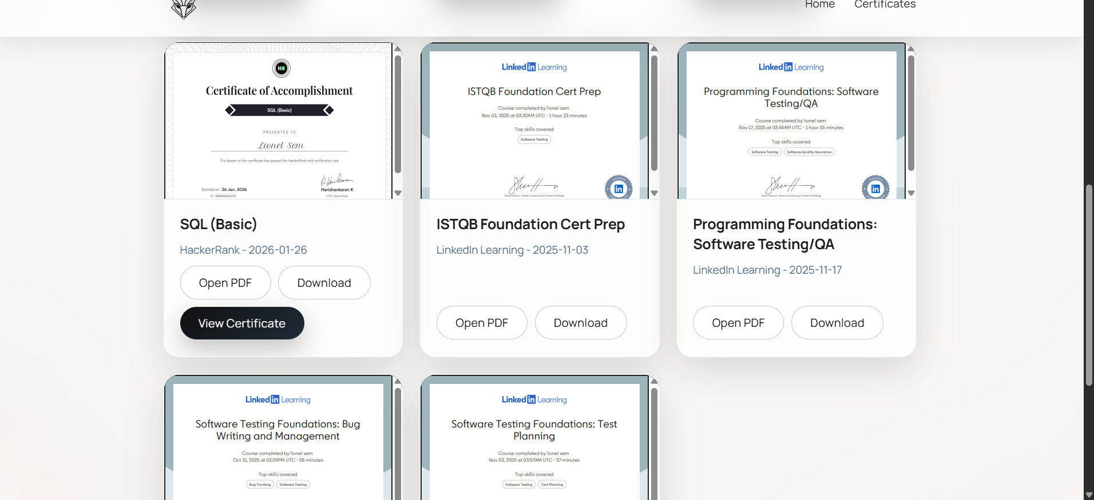

**Link to your Prototype – Most likely on Figma (make sure your lecturer is given access to the site)** *(To fill up for milestone 2 and 3)***:**

<https://www.figma.com/design/LrSEpybZkdZwhIf6Km2ZsY/Portfolio-Website?node-id=10-99&t=jHK0MysIaJft9rza-1>

**Reference sites** *(*Optional)***:**

*Any reference websites you have make references*

**https://www.figma.com/design/LrSEpybZkdZwhIf6Km2ZsY/Portfolio-Website?node-id=0-1&t=OIEwKqBW00DNVdTK-1**